Justin Zamecnik

Lab Report 8

Objectives:

Creating Starter GPO’s while also adding in ADMX and ADML files. We also will look into creating backups and troubleshooting techniques in Group Policy.

Equipment List:

The only equipment used for this lab was a pen and some paper and a laptop to remote desktop to the server and clients.

Notes and Observations:

This lab wasn’t too difficult. Once again, it was simply following what the book told us to do. We managed to get most of it done quickly. It primarily consisted of looking into the options for searches, creating Starter GPO’s and other things similar to that. Overall, it was straight forward.

Diagrams, flowcharts, and figures:

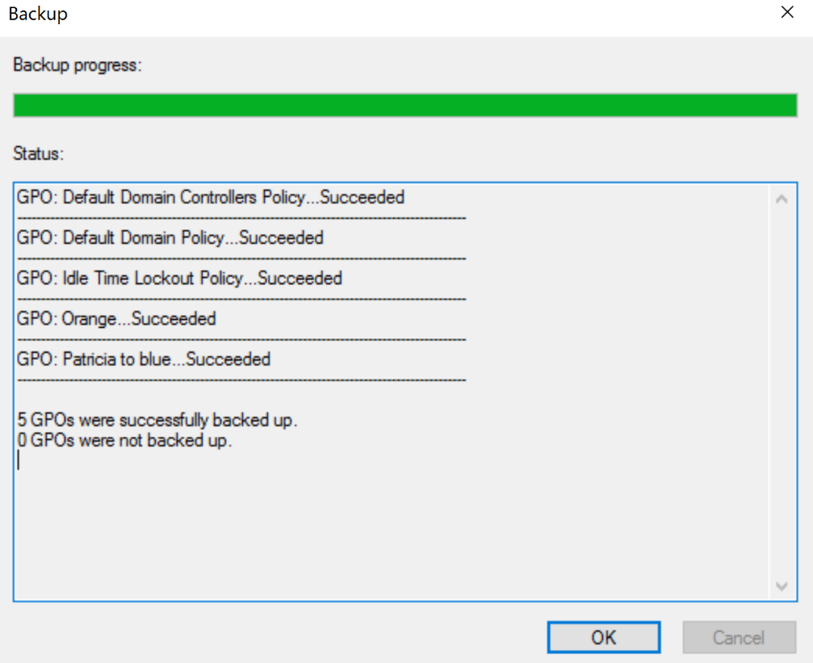

References:

No references were used in this lab.

Questions:

1.Why should you keep each GPO narrowly focused on just a narrow group on policy settings and give it a descriptive name?

This makes it much easy to keep track of in the long run, plus it’s easier to maintain. If you were to make one large GPO that covered a lot, it would require you to shut down a large portion just to fix a minor problem.

2.What useful information should be included in the Comment field of a policy setting?

Typically a description of what the GPO does is the most convenient.

3.Why might it be important to run GPO reports?

If everything goes wrong and there is a failure, you can look into the printed reports and rebuild.

4.Give some examples of how searching and filtering can be used by a sys admin to manage policy settings.

The search tool would be handy for searching for specific GPOs. The filtering tool is for narrowing things down depending upon what is inside the GPO. Search would be convenient if you knew what GPO you were looking for, but filter would be better if you didn’t know the names of the GPOs that had a specific function, but you wanted to add something to those GPOs. You could simply narrow it down by that function and then select the GPOs that popped up.

5.Why might a sys admin want to take the time to set up starter GPOs?

They can be used as templates later on, which can save time.

6.What are two main reasons for backing up GPOs?

The two main reasons for back ups are for restoring what was lost, and for “historical rollback” as the book puts it.

7.What is the purpose of the “Central Store”?

It allows us to put all of the ADMX and ADML files into the same place, which are then all distributed to the Domain Controllers.

8.What does the command “gpudate” do?

The command is used to update group policies.

9.When running RSOP or GPUpdate, why might you need to run the commands once as an administrator and once as a standard logged­ in user?

This is simply because when they are ran they are typically only seen on one or the other.

10.What is the purpose of Group Policy Modeling?

It can be used to run a simulation based on a specific user computer, or containers can be specified for either the user or computer to simulate a GPO.

Conclusion and Reflection:

This lab wasn’t necessarily hard, but it was time consuming. The main reason for the time consumption was trying to get everyone in the group together to get things done. We had some problems getting to that point, but we managed to get things together and get it done. We had issues communicating for the first time sense the online classes began, so I guess it was bound to happen. Thankfully, the lab was basically following along with the book again, so any problems we had were right in front of us. Overall, the lab wasn’t too bad. Communication was off, but that was it. It took us more time than it should have to get the lab done, which is why this is being turned in late.